ASSIGNMENT – 4

Name: Shabesh

Write a code and connections in wokwi for ultrasonic sensor. Whenever distance is less than 100 cms "send" alert to IBM Cloud and display in device recent events.

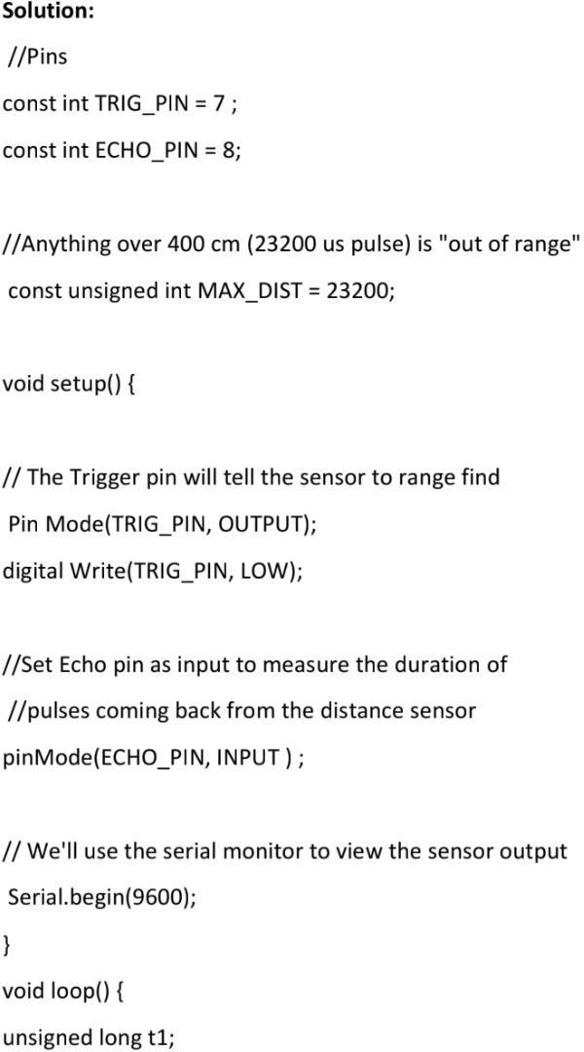

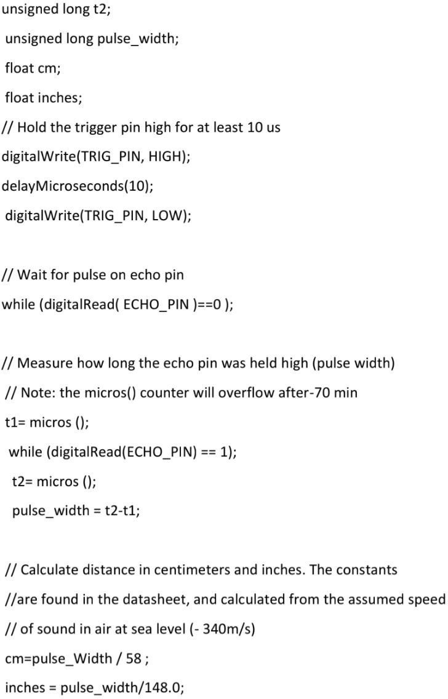

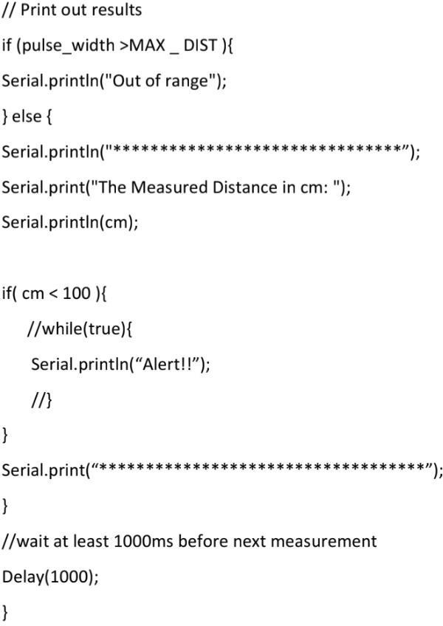

**OUTPUT:**

